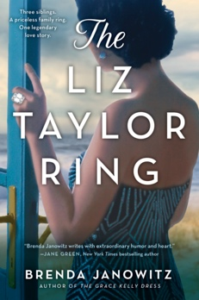

READING GROUP GUIDE
THE LIZ TAYLOR RING
By Brenda Janowitz

1. Family stories are an important part of The Liz Taylor Ring. Which family stories morphed or changed as we saw them through the eyes of different characters? Which family stories turned out to be true or false? Do you have any family stories that have changed over time? Stories that different relatives remember differently?

2. Each sibling wants the ring for a different reason. Do you have heirlooms in your family? How were they distributed? Why did each family member want the item?

3. Addy tells Emma that wearing jewelry feels like wearing armor. Do you agree or disagree with this statement? Do you have a favorite piece of jewelry?

4. Who was your favorite Schneider sibling? Why? Who did you relate to most?

5. If you have siblings, what is your relationship like with them? How do you think you would have reacted differently or similarly to the Schneider siblings in the same situation?

6. Did you understand Lizzie’s decision to choose Ritchie over her family?

7. How do you think the Schneider siblings’ own love stories will influence their own children?

8. The characters often remark that “two things could be true at once.” Do you believe this sentiment to be true?

9. What’s your favorite Elizabeth Taylor movie?

10. What’s your favorite piece of Elizabeth Taylor’s jewelry?

